

LjunggrenAudio RYO Boolean Logic Series:
Discrete Resistor-Transistor-Logic.

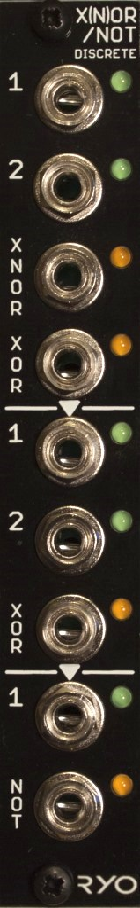

- directly modelled on RTL digital logic gate designs pioneered in the 1950s used in computing equipment throughout the 50s and 60s.
- can be used as audio waveshaper/distortion.
- The XNOR/XOR/NOT module can be patched as:
- two NOT gates and one 2-input XOR gate,
- one NOT gate, one 2-input XOR gate and one 2-input XNOR/XOR gate,
- two 2-input XNOR/XOR gates, or,
- one NOT gate and one 3-input XNOR/XOR gate.
- All analogue circuitry.
- slim 4HP footprint.
- compact 50mm Depth (with power cable attached).
- low power draw: 28mA +12V / 0mA -12V / 0mA +5V.
- Works for audio as well as CV.
- Fast responding CV inputs allow up to audio rate operation.
- The XOR out from gate one is normalized to input 1 on gate two.
- The XOR out from gate two is normalized to the single input on gate three (NOT).
- signal indicator LEDs on every input and output.
- can accept input signal to +10V peak.

downloads
* user manual
* quickstart guide
* assembly guide
* hi-res schematic
* datasheet
* BOM

